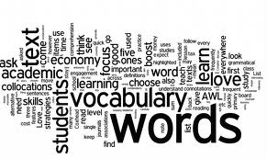

Revision Strategy—Amazing Adjectives

An excellent way to revise a rough draft is to require students to revise for word choice by focusing on adjectives. Ask students to circle all of the adjectives in their first draft. They can do this alone, or by collaborating with other students at their table groups. I prefer to give students time to work on the task individually, and then ask that they work with a shoulder partner and/or table group.
After circling adjectives, I instruct students to find substitutions for their word choices by using adjectives from our amazing adjective list. This will most likely require students to use the dictionary or thesaurus to determine meanings for some of the adjectives. You are bound to get a few questions too. Ask students to have a goal to use each adjective at least one time in their writing during the school year. Students in my classes highlight words they use, and they also develop a list of their favorite adjectives. Revision for adjectives appears on checklists for all writing, and becomes a strategy that students own and use throughout the year.

